

“The ultimate electric wagon”
Electricbeachwagons.com LLC
351 West 130th St.
Los Angeles. CA, 90061

Congratulations and thank you for your purchase of your new Sandhopper® electric wagon!

PLEASE read the entire owner’s manual BEFORE operating your new Sandhopper®. It contains important safety information about the use and care of your product. Your Sandhopper® is not a toy. It is motorized and self-propelled. It is powerful and heavy enough that if misused it could damage property or injure people. READ AND FOLLOW ALL INSTRUCTIONS COMPLETELY.
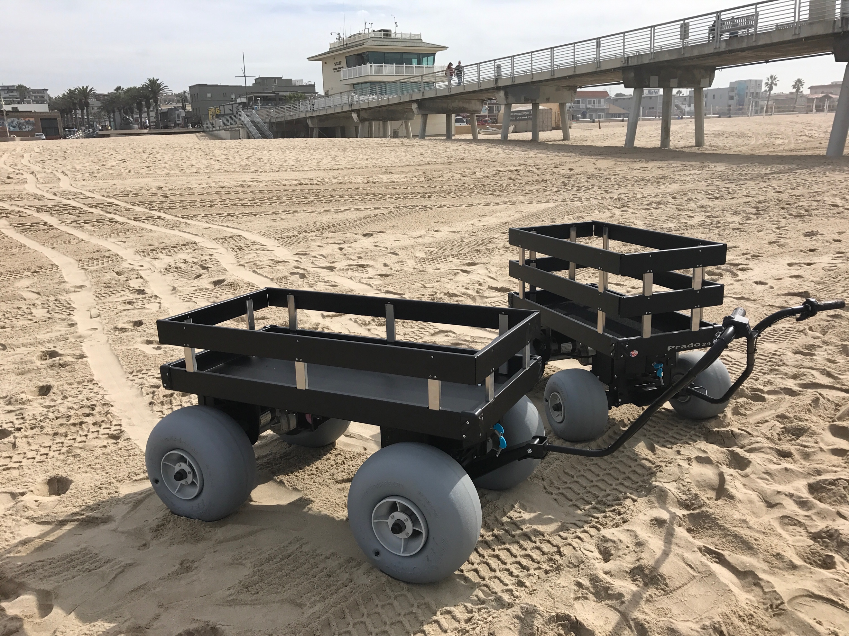

Getting to know your Sandhopper®

Sandhopper® is a battery powered electric beach wagon, capable of carrying significant cargo for 3 – 6 miles depending upon the weight of any cargo, the surface driven on and battery size.

Operation

To use your Sandhopper, locate the key and insert it in the key switch located on the control panel in front of the wagon and below the deck. (See diagram 1). Turn the key to the right. NEVER LEAVE THE KEY IN WHEN YOU ARE NOT OPERATING THE SANDHOPPER - SOMEONE MIGHT ACCIDENTALLY INJURE THEMSELVES, OTHERS OR PROPERTY.

Check the battery condition by inspecting the battery meter located on the control panel to the right of the key switch. Only operate the Sandhopper® when it is fully charged. Recharge the battery after every use. Always keep batteries fully charged with provided charger. (See charging instructions below)

Confirm the speed selection switch is set to the “LOW” position. The speed selector is located on the control panel beside the key switch.

Diagram 1

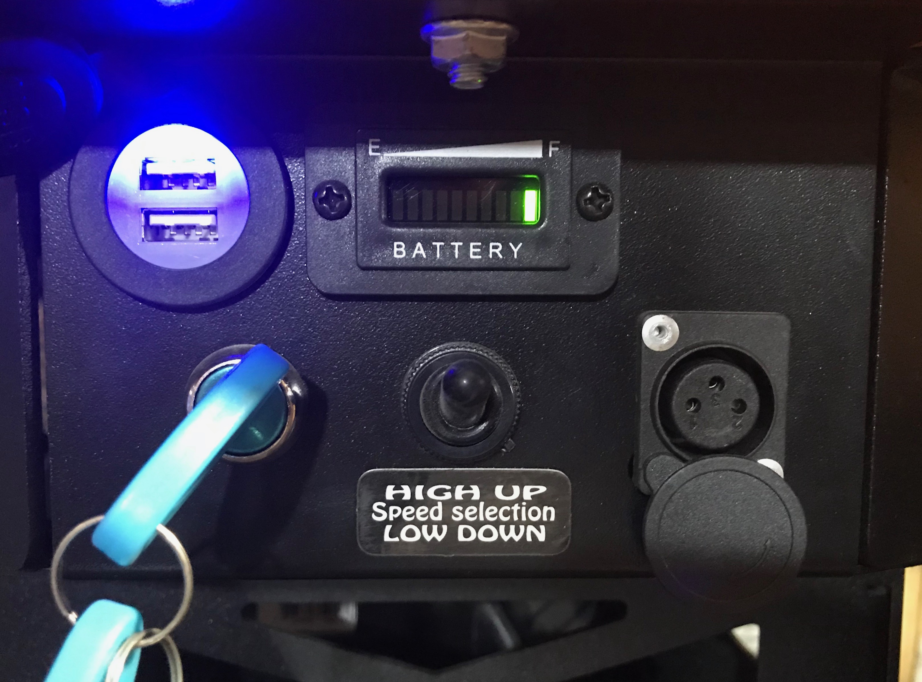

On the control handle, select either Forward or Reverse.
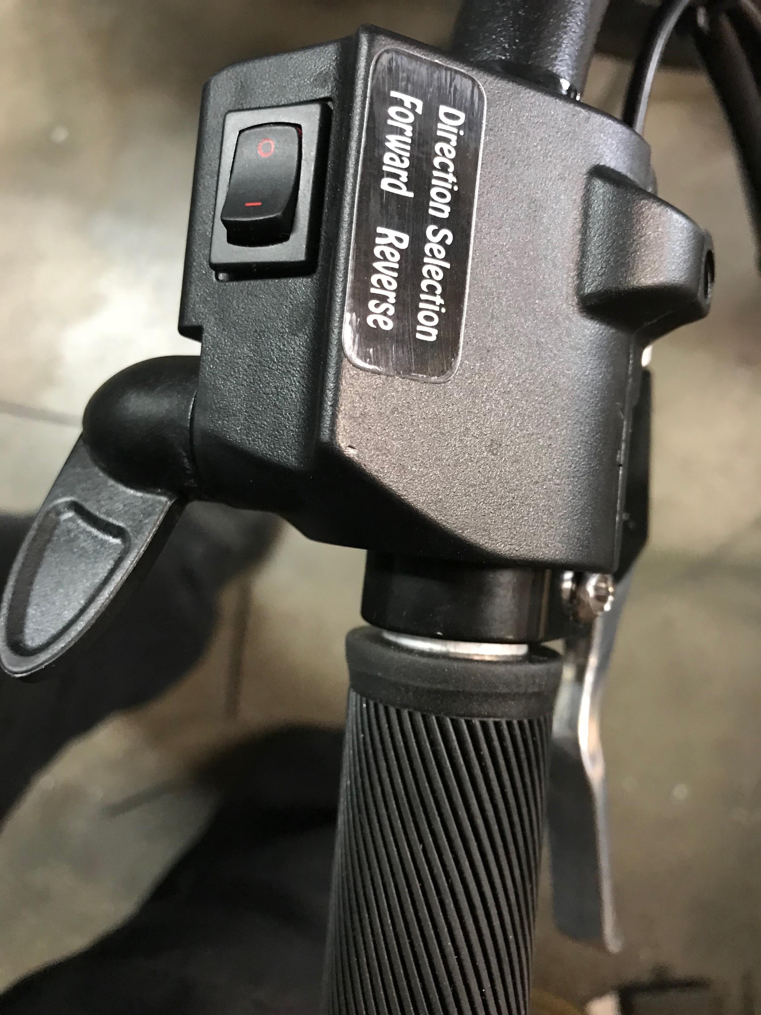
Release the parking brake by squeezing the brake lever. ALWAYS SET THE PARKING BRAKE BEFORE TAKING YOUR HAND OFF THE CONTROL HANDLE FOR ANY REASON.
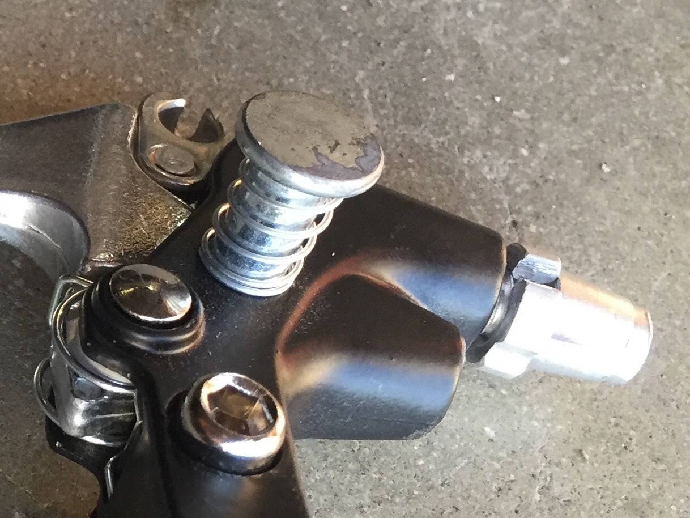

To set the parking brake, squeeze the brake lever with one hand and push down on the parking brake button to lock the brake in place. To release the parking brake, simply squeeze the brake lever and the parking brake button will release.
To move the Sandhopper® Forward or Reverse, gently depress the thumb throttle on the control handle to engage the electric motor. It only takes a slight amount of pressure on the throttle to engage the electric motor. Keep in mind that the Sandhopper® is made for sand and for carrying gear, as a result the power and speed is greater on a hard surface or when the wagon is empty.

In an open area, practice controlling the speed and steering characteristics of the Sandhopper®. STOP: Do not operate further without reading the balance of these instructions.
A reminder: Always use the Low-speed setting. The High-speed feature would be needed only when you are carrying a very large payload and/or ascending an uphill grade, to provide extra power.

…… Understanding Regenerative Braking
Your Sandhopper® has regenerative braking/charging which operates when descending a hill or incline. This means the smart controller system in your Sandhopper® takes advantage of gravity. By using the forward momentum of the wagon, the rotation of the rear wheels generates an electrical charge that is sent back to the batteries for the purpose of recharging them. In some situations, depending on how steep the grade is, it may seem like the wagon is dragging even when you remove your thumb from the throttle. However, the regenerative braking system is actually restricting the speed of the wagon. THIS FEATURE ONLY WORKS WHEN THE KEY IS ON. THE WAGON WILL ROLL FREELY WITH THE KEY IN THE OFF POSITION. Also, when descending a grade that is a smooth surface, such as wooden beach access ramp, the rear balloon style tires may lock up causing the wagon to slide. This is because the regenerative braking is causing the tires to turn more slowly resulting in the rear tires sliding on the smooth surface. Though ideal for the sand, these tires have little to no traction on smooth surfaces that are also inclines. In this situation, simply back the Sandhopper® down the incline / ramp, rather than walk in front of it. The operator is then in a better position to slow the wagon’s descent if necessary. ALWAYS USE EXTREME CAUTION WHEN DESCENDING AN INCLINE THAT IS A SMOOTH SURFACE SUCH AS WOODEN RAMPS, ESPECIALLY IF THERE IS LOOSE SAND PRESENT. RAMPS OR INCLINES THAT ARE A STEEPER GRADE THAN HANDICAP RAMPS SHOULD NOT BE USED. IF YOU DETERMINE THE INCLINE / RAMP SURFACE CONDITIONS ARE SLIPPERY FOR PEOPLE TO WALK ON, ANTICIPATE THAT THE SAME WILL BE TRUE OF THE SANDHOPPER WHEN EQUIPPED WITH BALOON TIRES AND FOLLOW THE PRECAUTIONS OUTLINED ABOVE.

Unless your wagon has been equipped for hill climbing, with the optional higher amperage controller, the standard smart controller may automatically shut off if asked to perform excessive climbing under load. After several minutes, the wagon will operate again as normal.

When ascending or descending hills, always take a straight up or down approach. Never traverse a slope sideways potentially causing the wagon to roll over.

Avoid exposing the wagon to the elements such as rain. Spraying your Sandhopper® with fresh water after each use is encouraged. Just don’t ever spray a jet of water towards the control panel as electronic circuitry may be damaged by water intrusion. NEVER take your Sandhopper® through standing water.

Sandhopper® should be operated by adults only. Never let anyone under 18 operate your Sandhopper® and every operator is required to read the owner’s manual.

After reaching your destination set the parking brake as described above.

Always remove the key when not in use. In the event you inadvertently leave the key in the ON position, the smart controller will go into sleep mode after 5 to 10 minutes. Turn the key off and then back on to reset the controller.

Never sit in the Sandhopper® wagon and attempt to drive. It is not designed to be driven. The weight of a driver directly over the steering wheels may severely restrict the steering. SERIOUS INJURY OR DEATH MAY OCCUR. Additionally, local laws may prohibit the operator from using the Sandhopper® as a motorized vehicle.

The type of tires on each Sandhopper® determines the maximum load capacity. See your specific tire for this information. Don’t forget to deduct the weight of the wagon when determining load capacity. However, it is not recommended that you regularly carry heavy loads (over 250 pounds) without adding certain options such as the larger controller. It is also important to familiarize yourself with the Wheeleez® manufacturer’s suggestions that are found in the owner’s pamphlet or on their website. Most importantly, never inflate the Wheeleez® tires with more than 3 to 4 pounds of air. Never use an electric or commercial air pump. ONLY use a hand pump such as what you may use to pump up a bicycle tire. Also, it is recommended that you have an air gauge that is designed to detect low air levels such as 3 to 4 pounds. (Milton Model # S931)

Children should never be left unattended. To help insure everyone’s safety, remove the key when loading any cargo.

Avoid operating the wagon on public or private roads whenever possible. Use pedestrian friendly sidewalks and paths. Never operate the Sandhopper® in low or poor lighting conditions.

In the event the wagon will not operate, (no power) check the battery circuit breaker located under the cart near the battery. If the circuit breaker has tripped just simply press the black button on the circuit breaker.
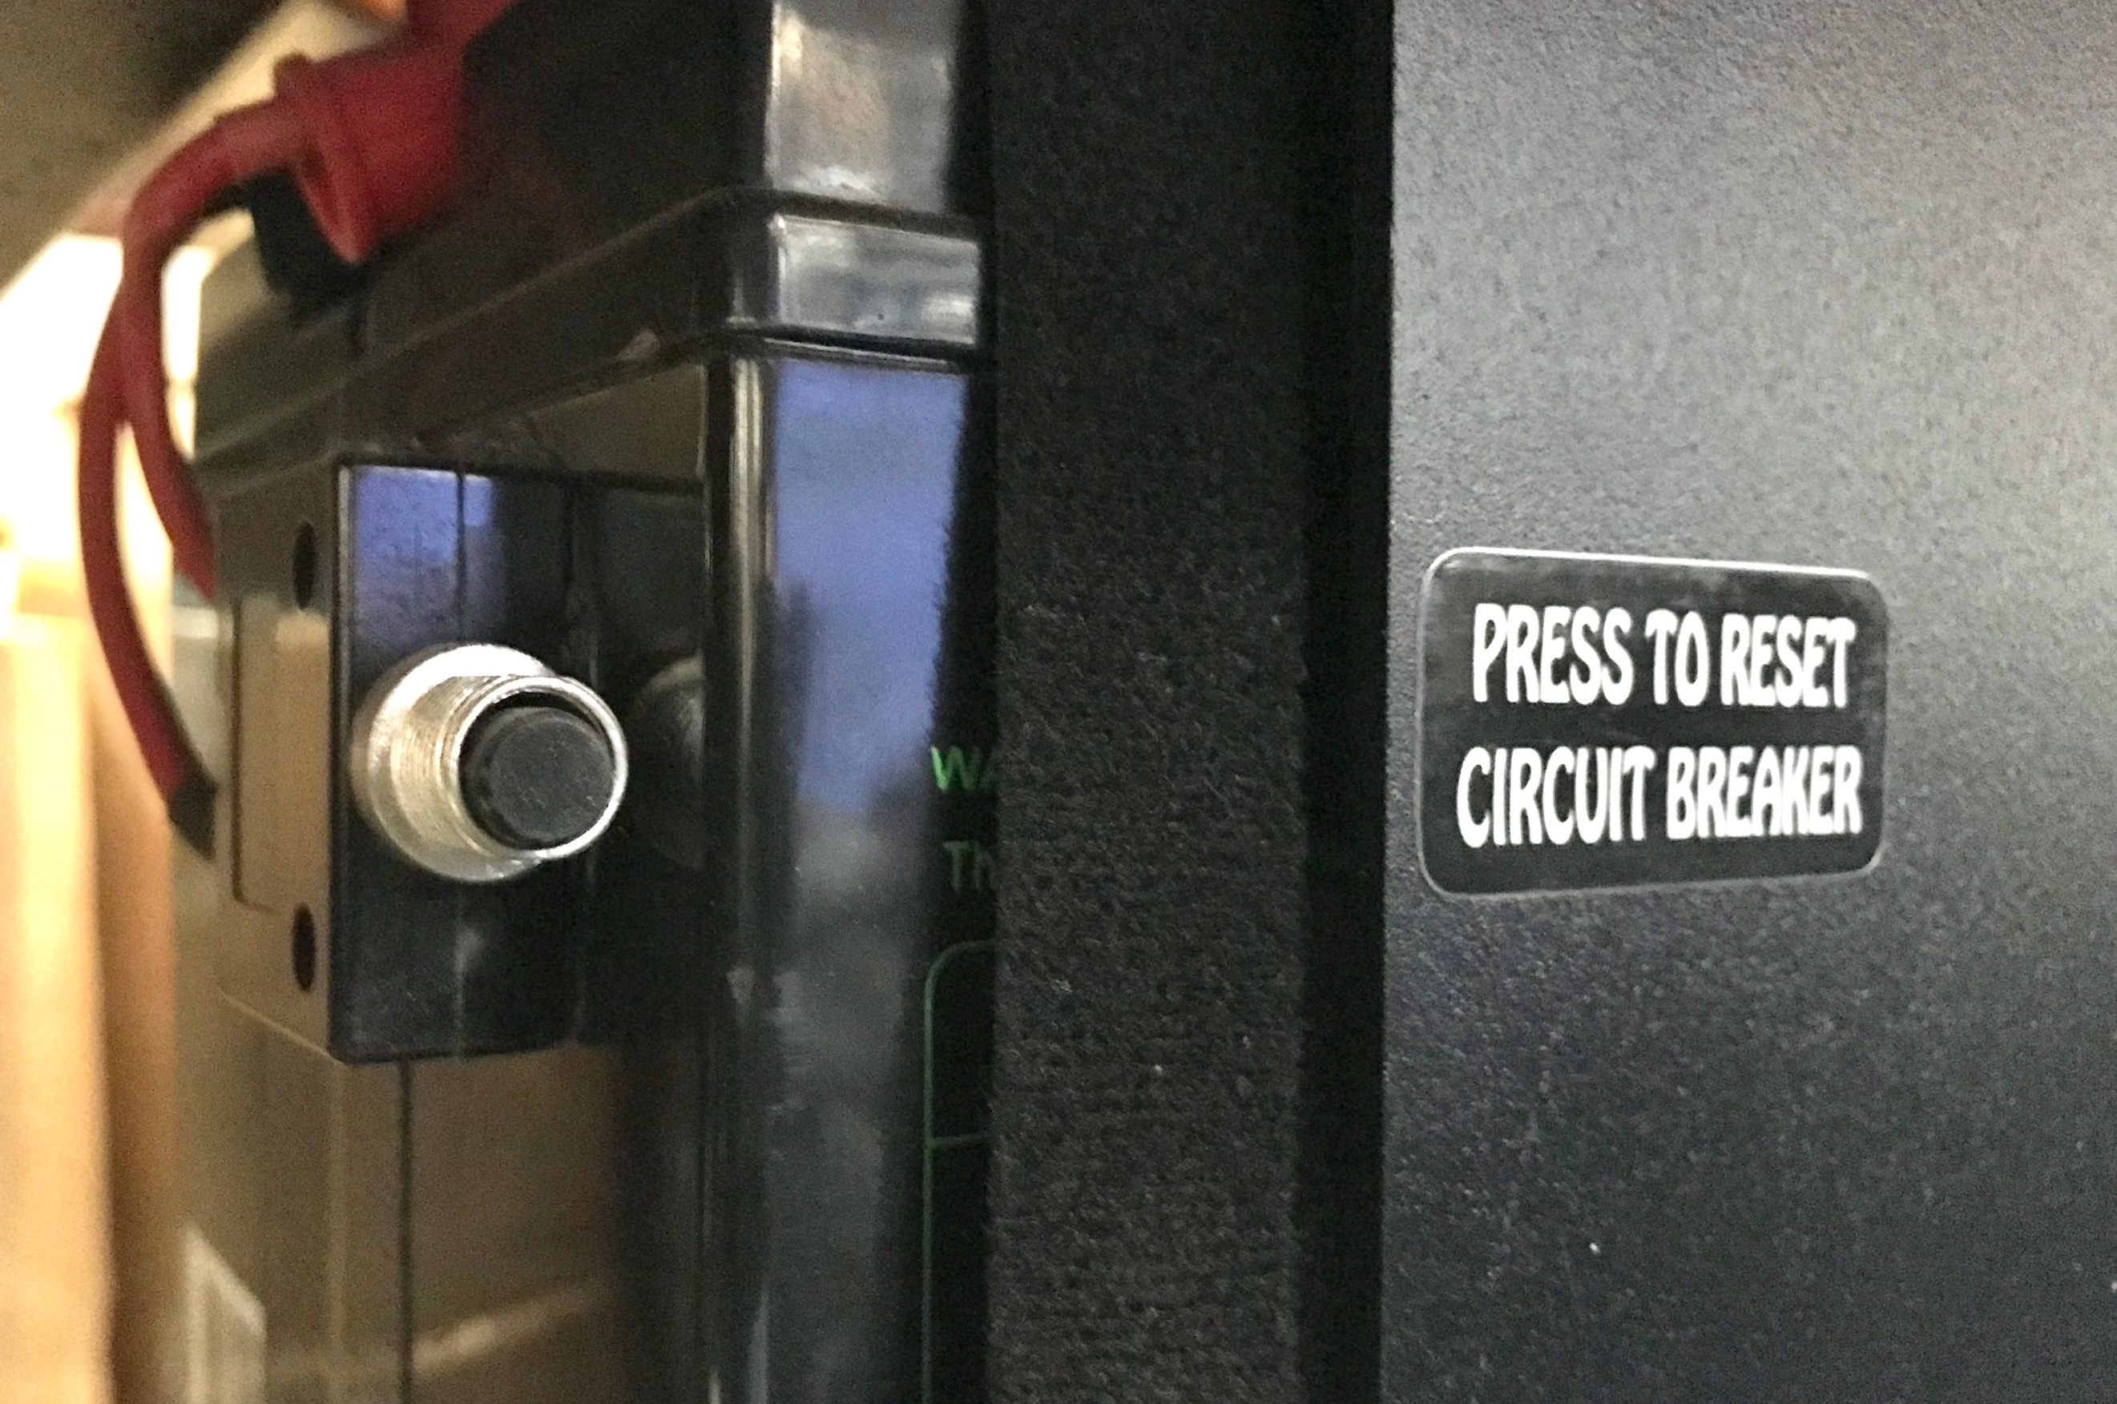

Battery maintenance

To recharge the battery, make sure the key is in the off position. Locate the Sandhopper® battery charging port on the control panel. (See diagram 1) To access the charging port ROTATE the dust cap to expose the charging port. DO NOT PULL on the dust cap. Now, plug the charger connector into the battery charging port. Next, plug the charger into your 110-wall outlet. The charger light will glow red while charging and green once fully charged.
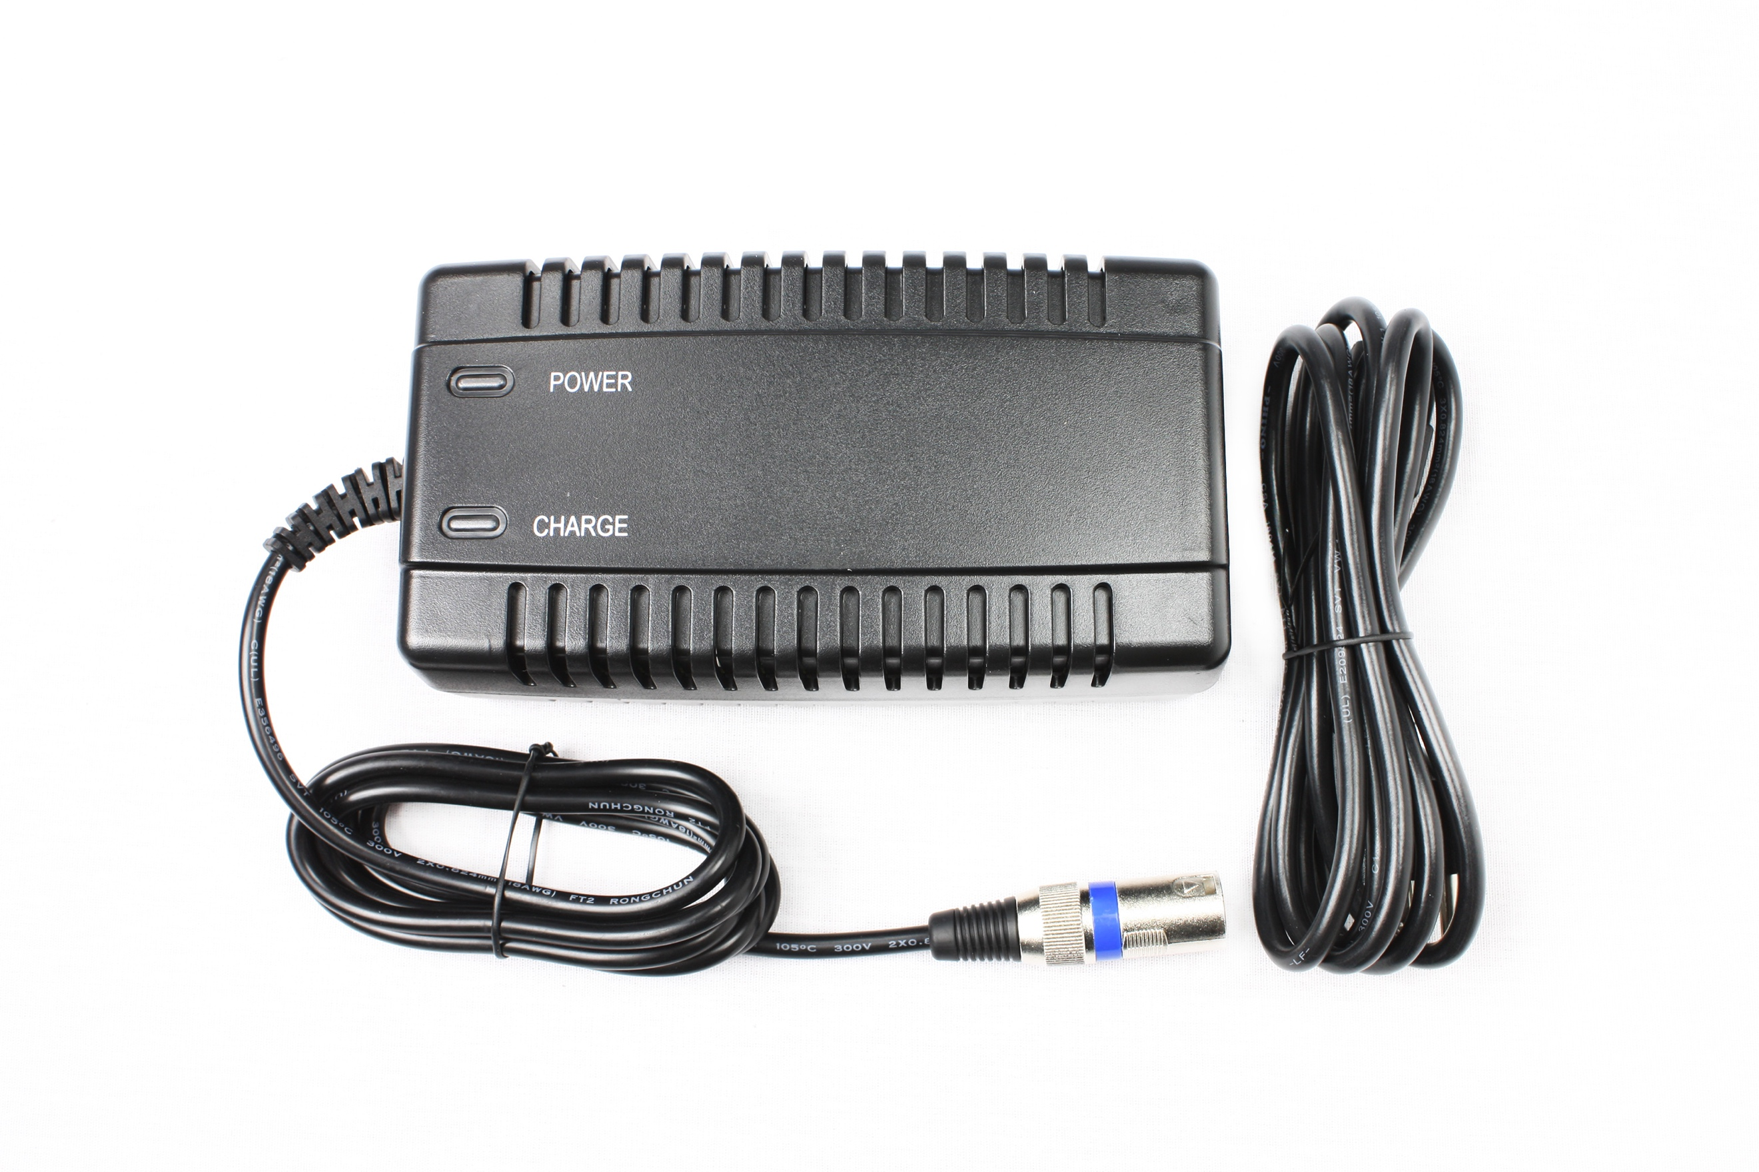
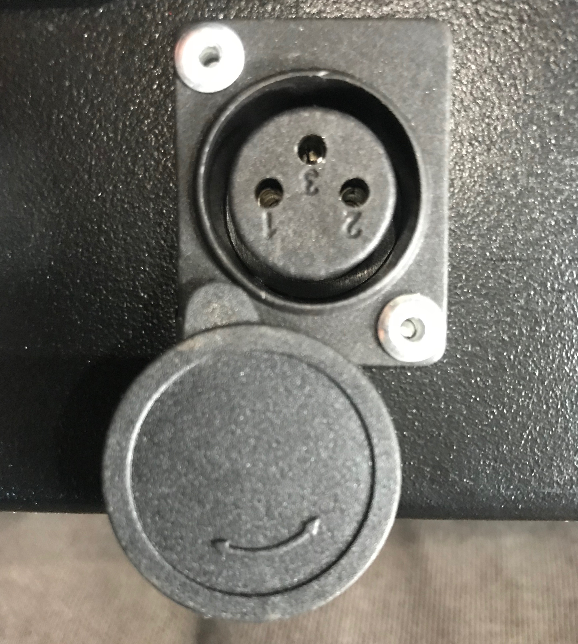

Always unplug the charger from the battery charging port first, then from the wall outlet. We recommend recharging the battery after every use. For best performance and battery life, never let the battery discharge below 60%.
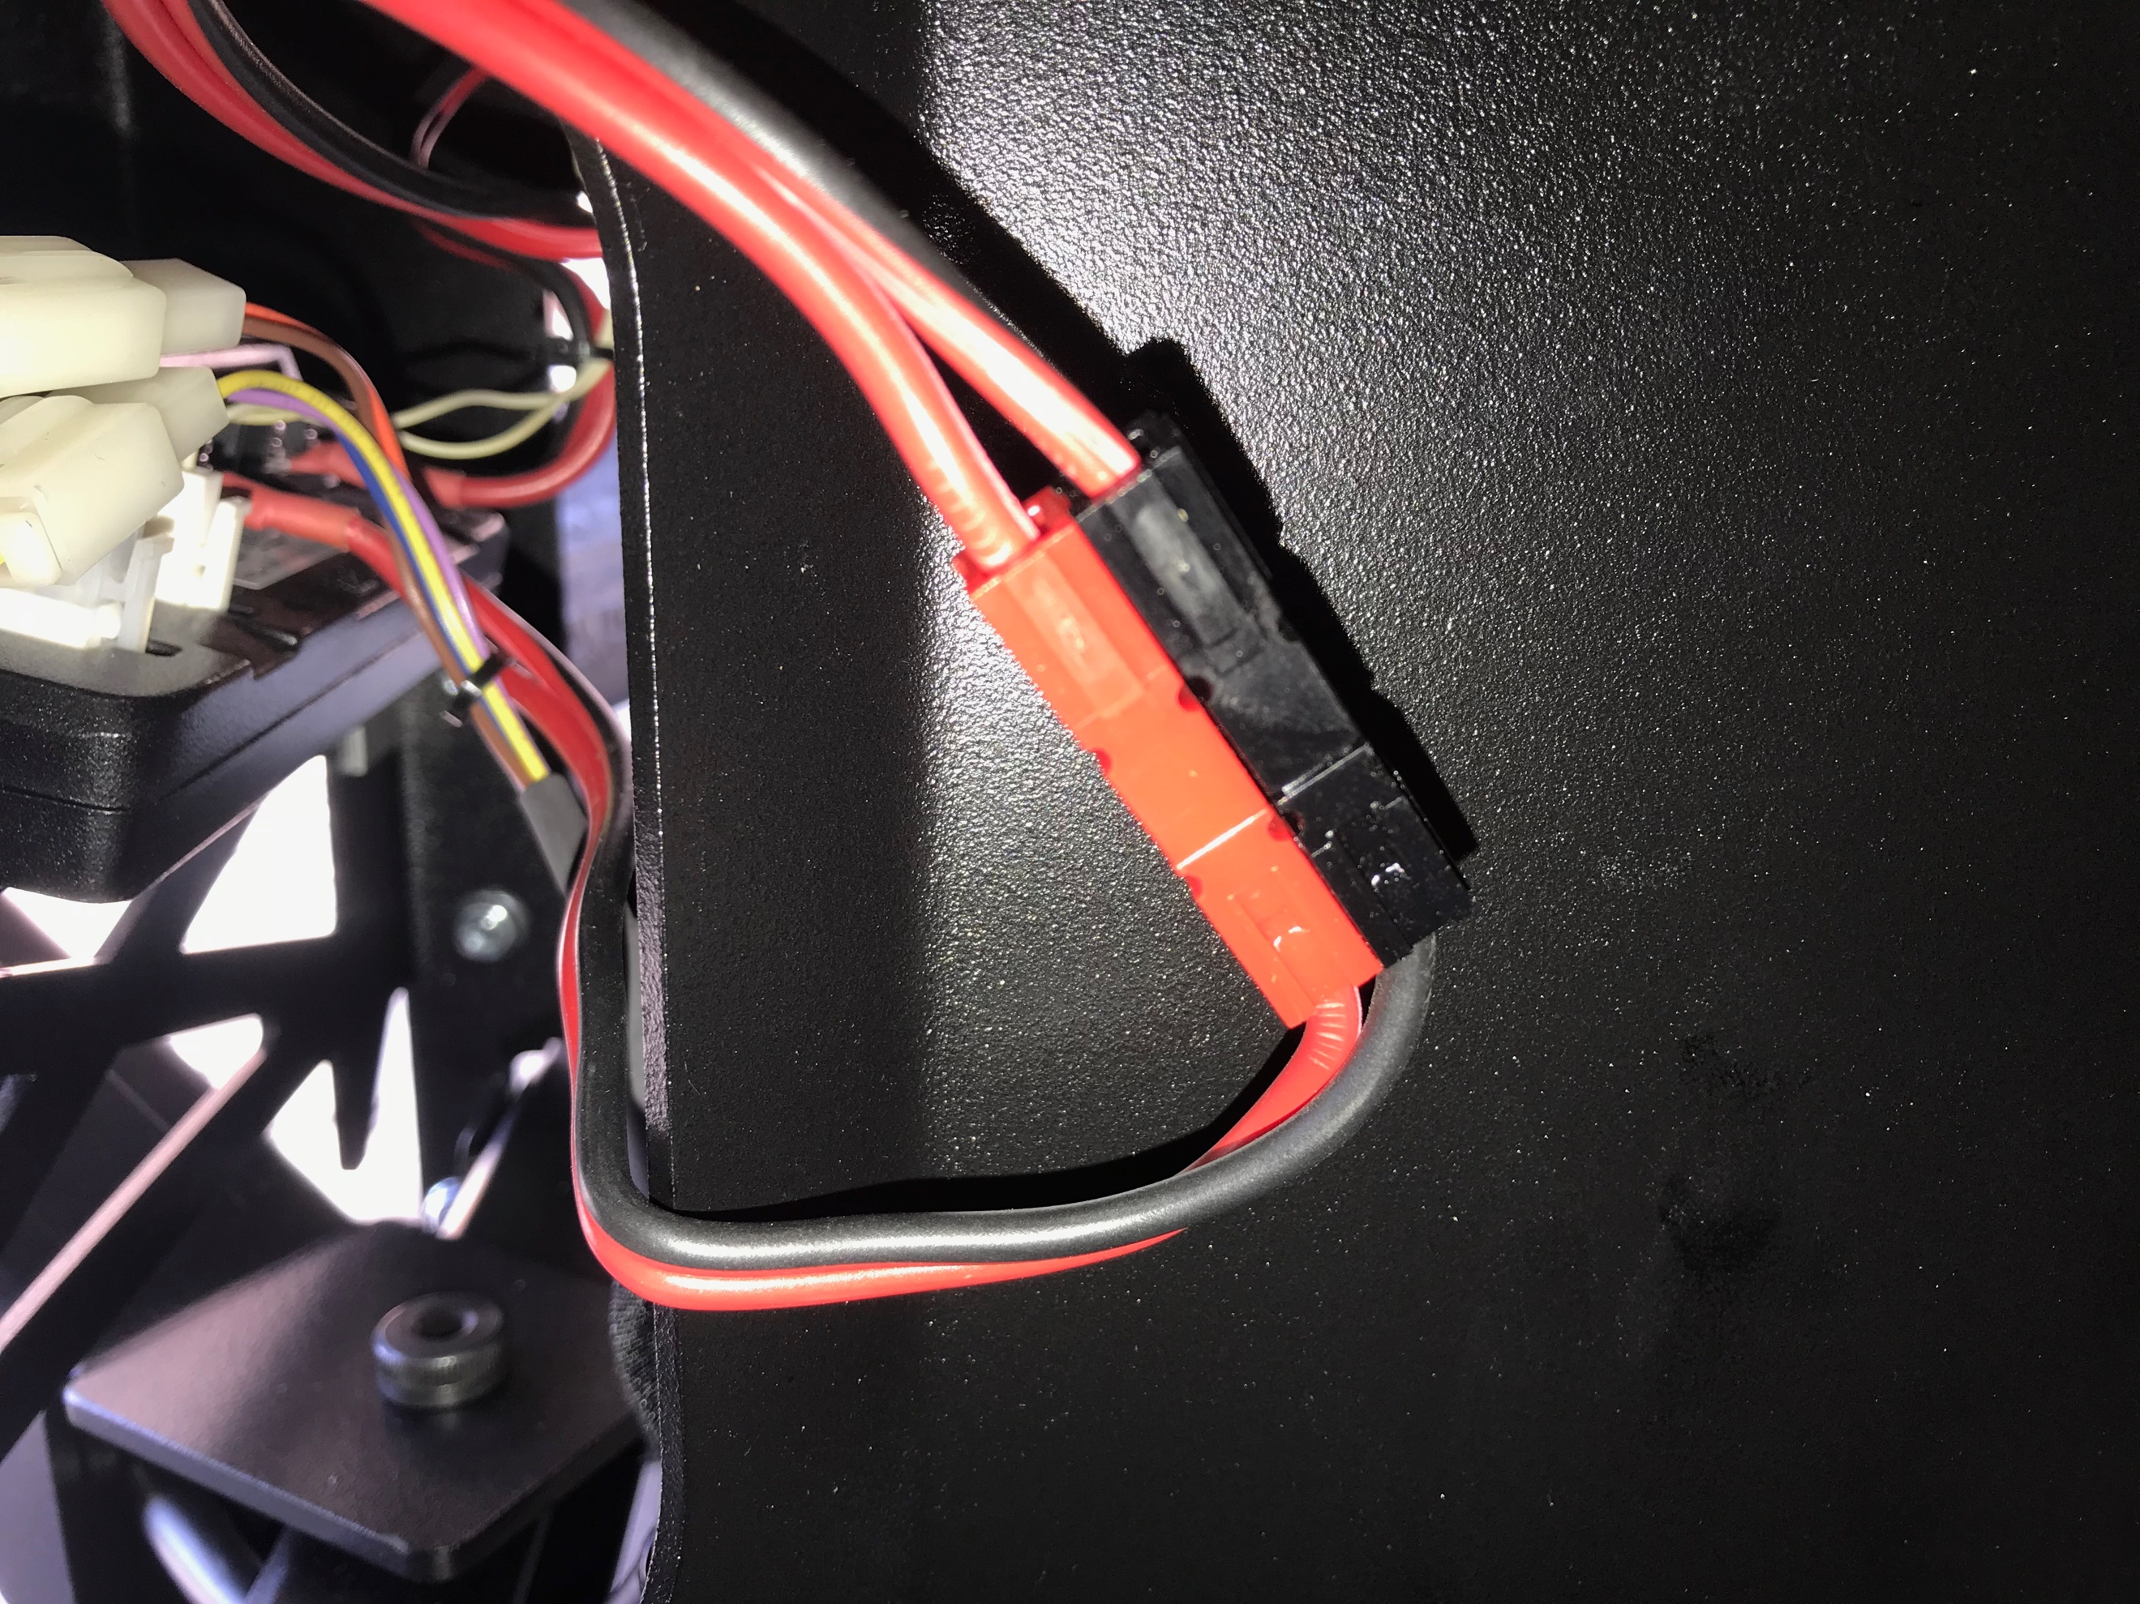

If you intend to not use the wagon for extended periods of time we recommend disconnecting the batteries after a full charge. The battery connector is located in the battery compartment.
Disconnect the RED and BLACK connector.

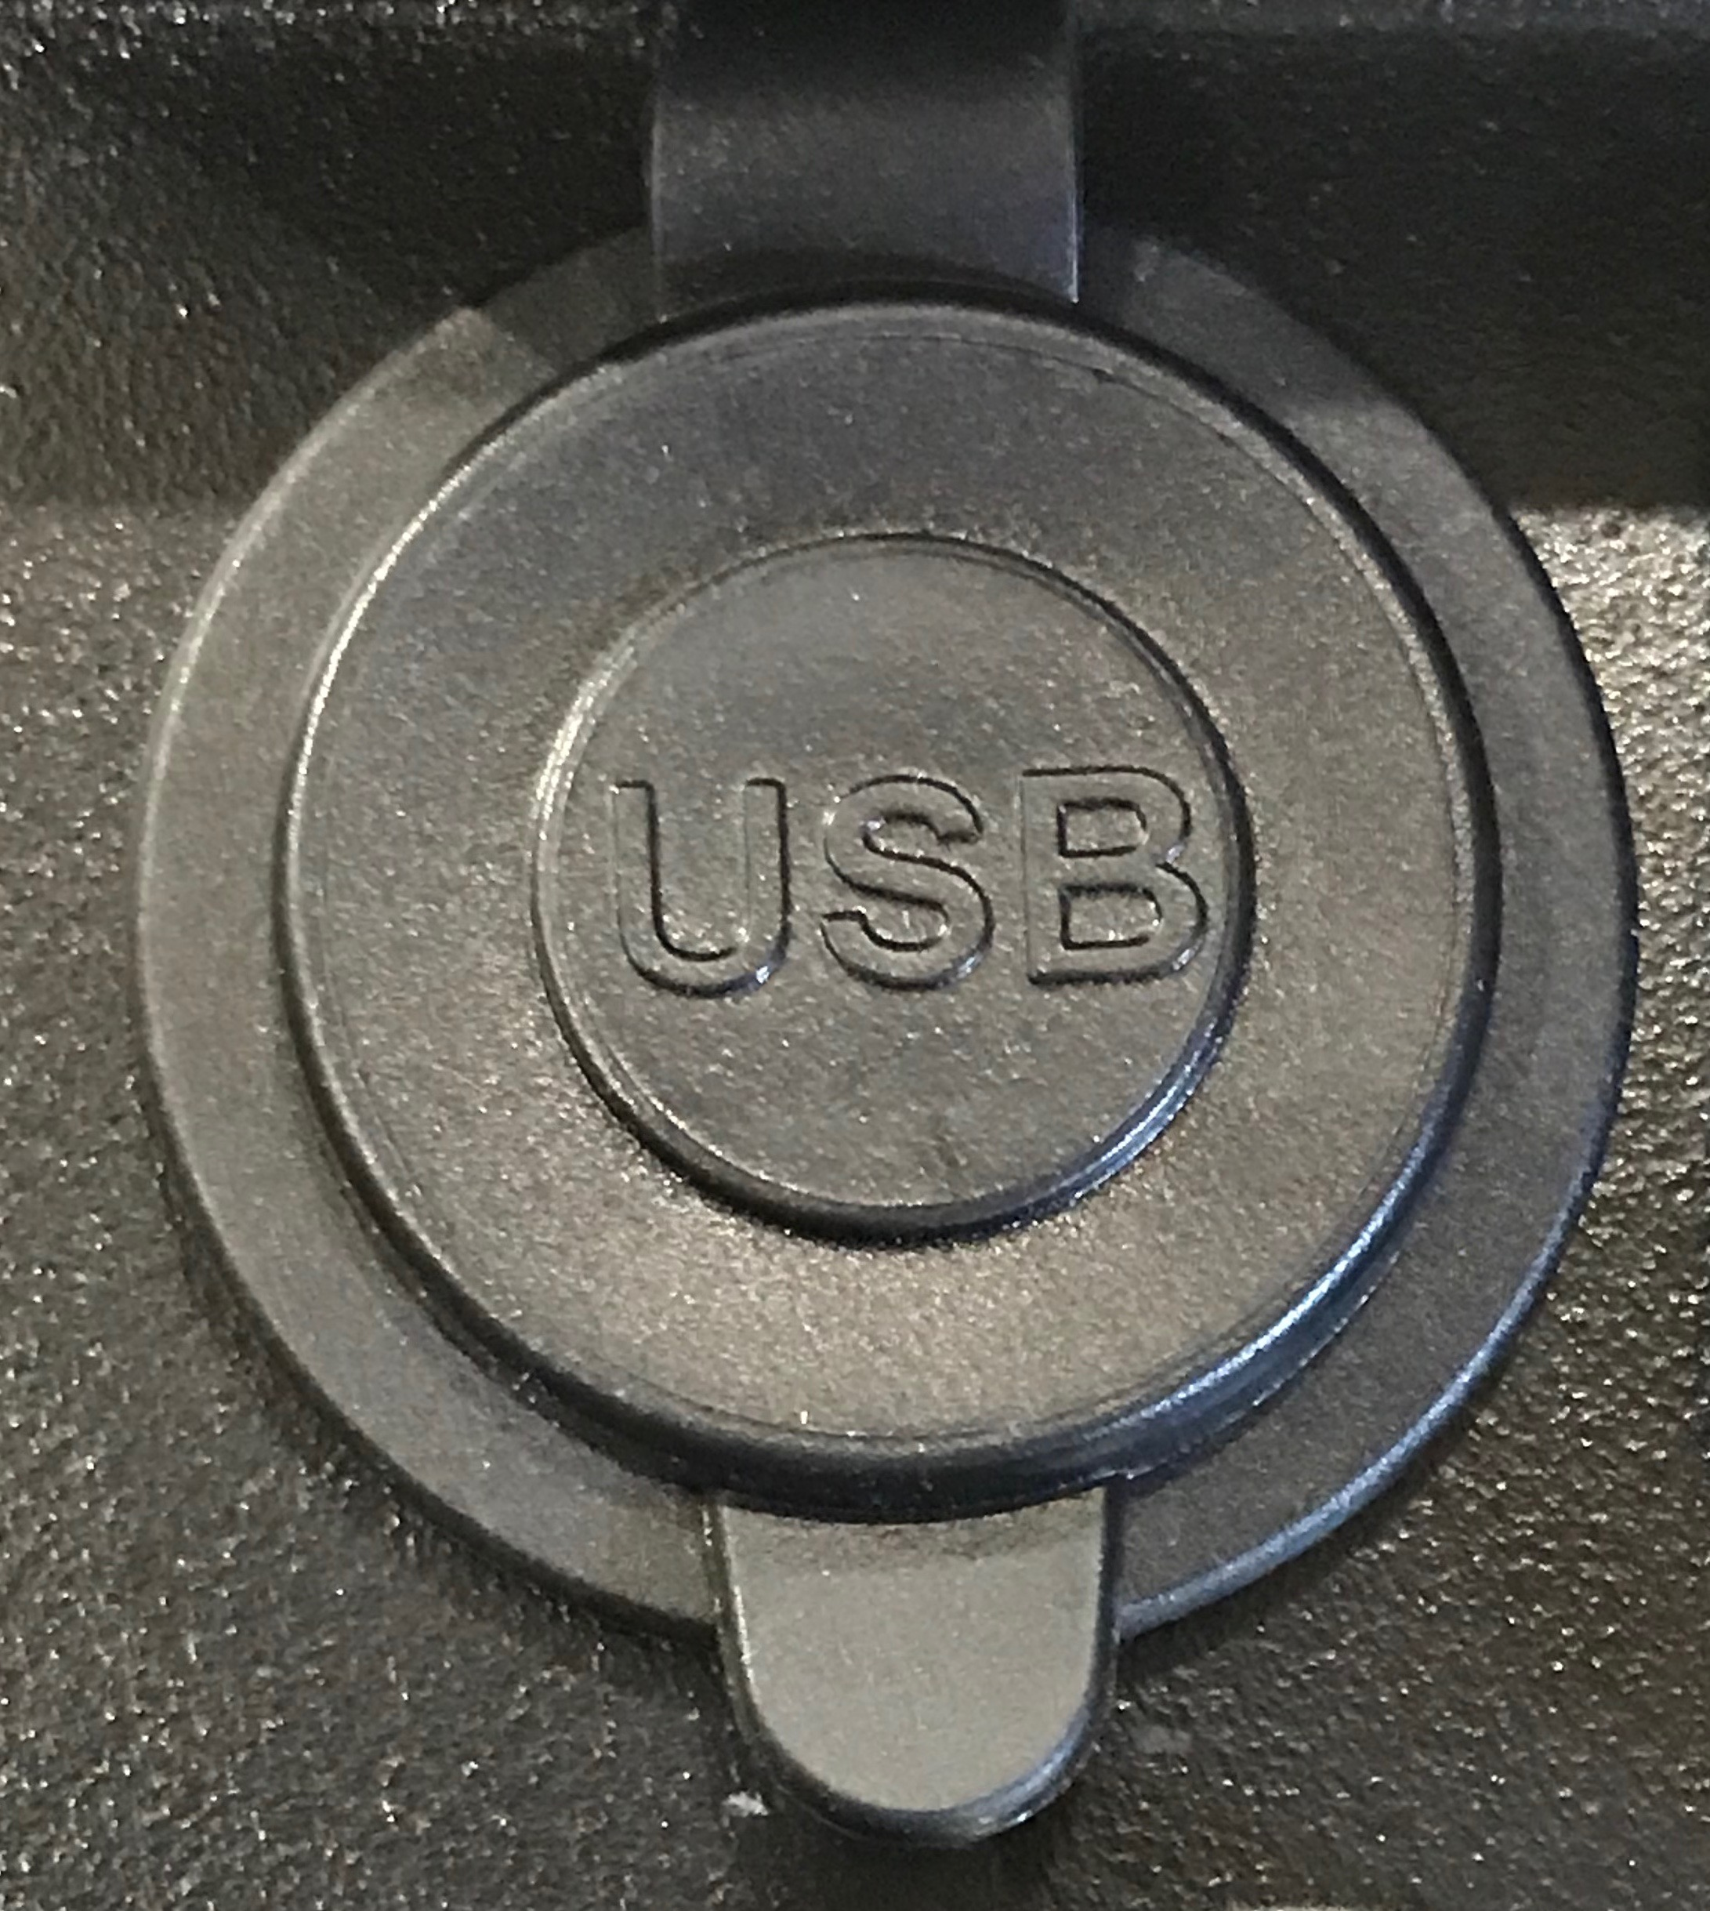
The optional DUAL USB port is located in the top left of the control panel. It may be used to recharge a mobile device.
It is only powered on when the key switch is in the ON position.

The Sandhopper® is sold with 2 unique keys, they WILL NOT WORK on any other Sandhopper®. If you lose your keys you will need to order a complete new set of keys and a key switch assembly. This replacement part is only available from the manufacturer. Duplicate keys are not available for purchase, but copies of your original key can be made at your local locksmith.

Sandhopper® Models with Auto brake/Auto Park Brake system

Sandhopper® models with Autobrake/Autopark models DO NOT have a rear disk brake or brake lever on the control handle. This model has an actuator on the rear drive motor.
To activate the Autobrake/Autopark feature lift up on the actuator lever, (located under the wagon in front of the rear wheels) to set the wagon in free wheel mode press down on the actuator. When the Autobrake/Autopark feature is deactivated the wagon will be able to be moved freely. The key switch must also in the OFF position.
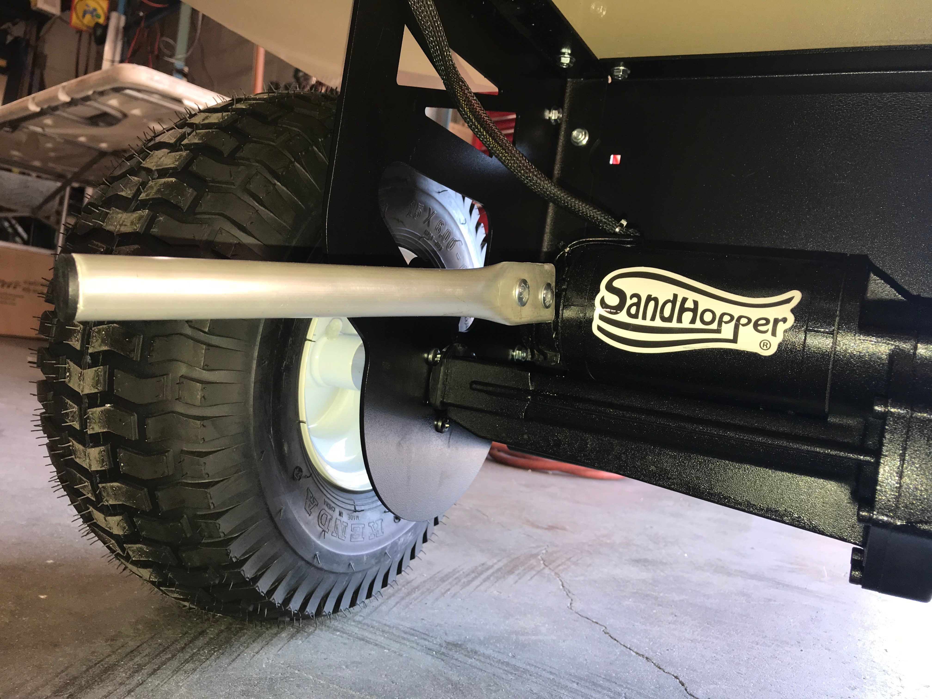
Caution: If the wagon is on an incline the wagon will roll freely and can roll away. Always make sure that the Autobrake/Autopark feature is set when the operator is using the wagon.
The Autobrake/Autopark feature should only be used in the deactivated position if battery power is lost and operator has full control of the wagon. To operate make the wagon in forward or in reverse presses gently on the throttle. This will auto disengage the Autobrake/Autopark and the wagon will move in the direction the operator selected. When the wagon comes to a full stop the Autobrake/Autopark will automatically re engage. acting like an emergency brake.

Side gates and Surf Rack Installation/Removal
The proper installation of the side rails (single and double rail) as well as the surf rack system are designed to be used as a complete set and of course work best when they are properly installed. First, make sure that nothing on the wagon deck is restricting the base of the railing posts from inserting as far as possible into their appropriate openings. A rubber mat or build-up of sand could keep the post from fully inserting into the deck. Next make sure each railing corner has properly mated together. (see diagram 2) Always insert the front and rear gates first, the sides last. Mate the corners while releasing the spring-loaded button at the base of the side rail post. (See diagram 3) Make certain that the button pops out once the gate is installed. If it doesn’t the railing system is in danger of coming out. CAUTION: The Surf Rack system when loaded with multiple boards or a large SUP or Kayak may cause a top-heavy condition especially if the wagon is empty of cargo. Use extreme caution when adding a significant amount of weight to the Surf Rack. Also, when attaching surfboards, SUP’s or a kayak, secure any straps, rope or bungee cords only to the end gates only and not the sides gates. This will help keep all the gates securely mated to one another which is critical to the strength of the system.

PROPER INSTALLATION IS ESSENTIAL! IF NOT PROPERLY INSTALLED, THE GATES MAY COME LOOSE OR COME OUT COMPLETELY.

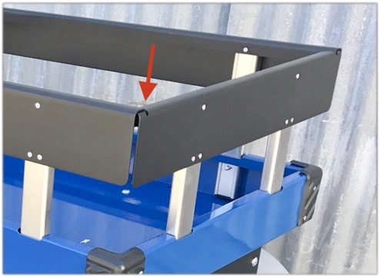

Diagram 2

Release/Lock snap pins are located at the bottom of the vertical support beams.

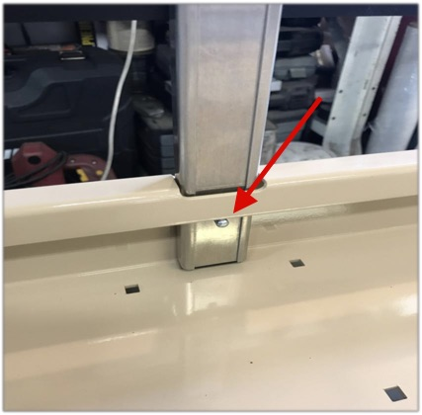
Diagram 3

Double side gates have interlocking corners also.

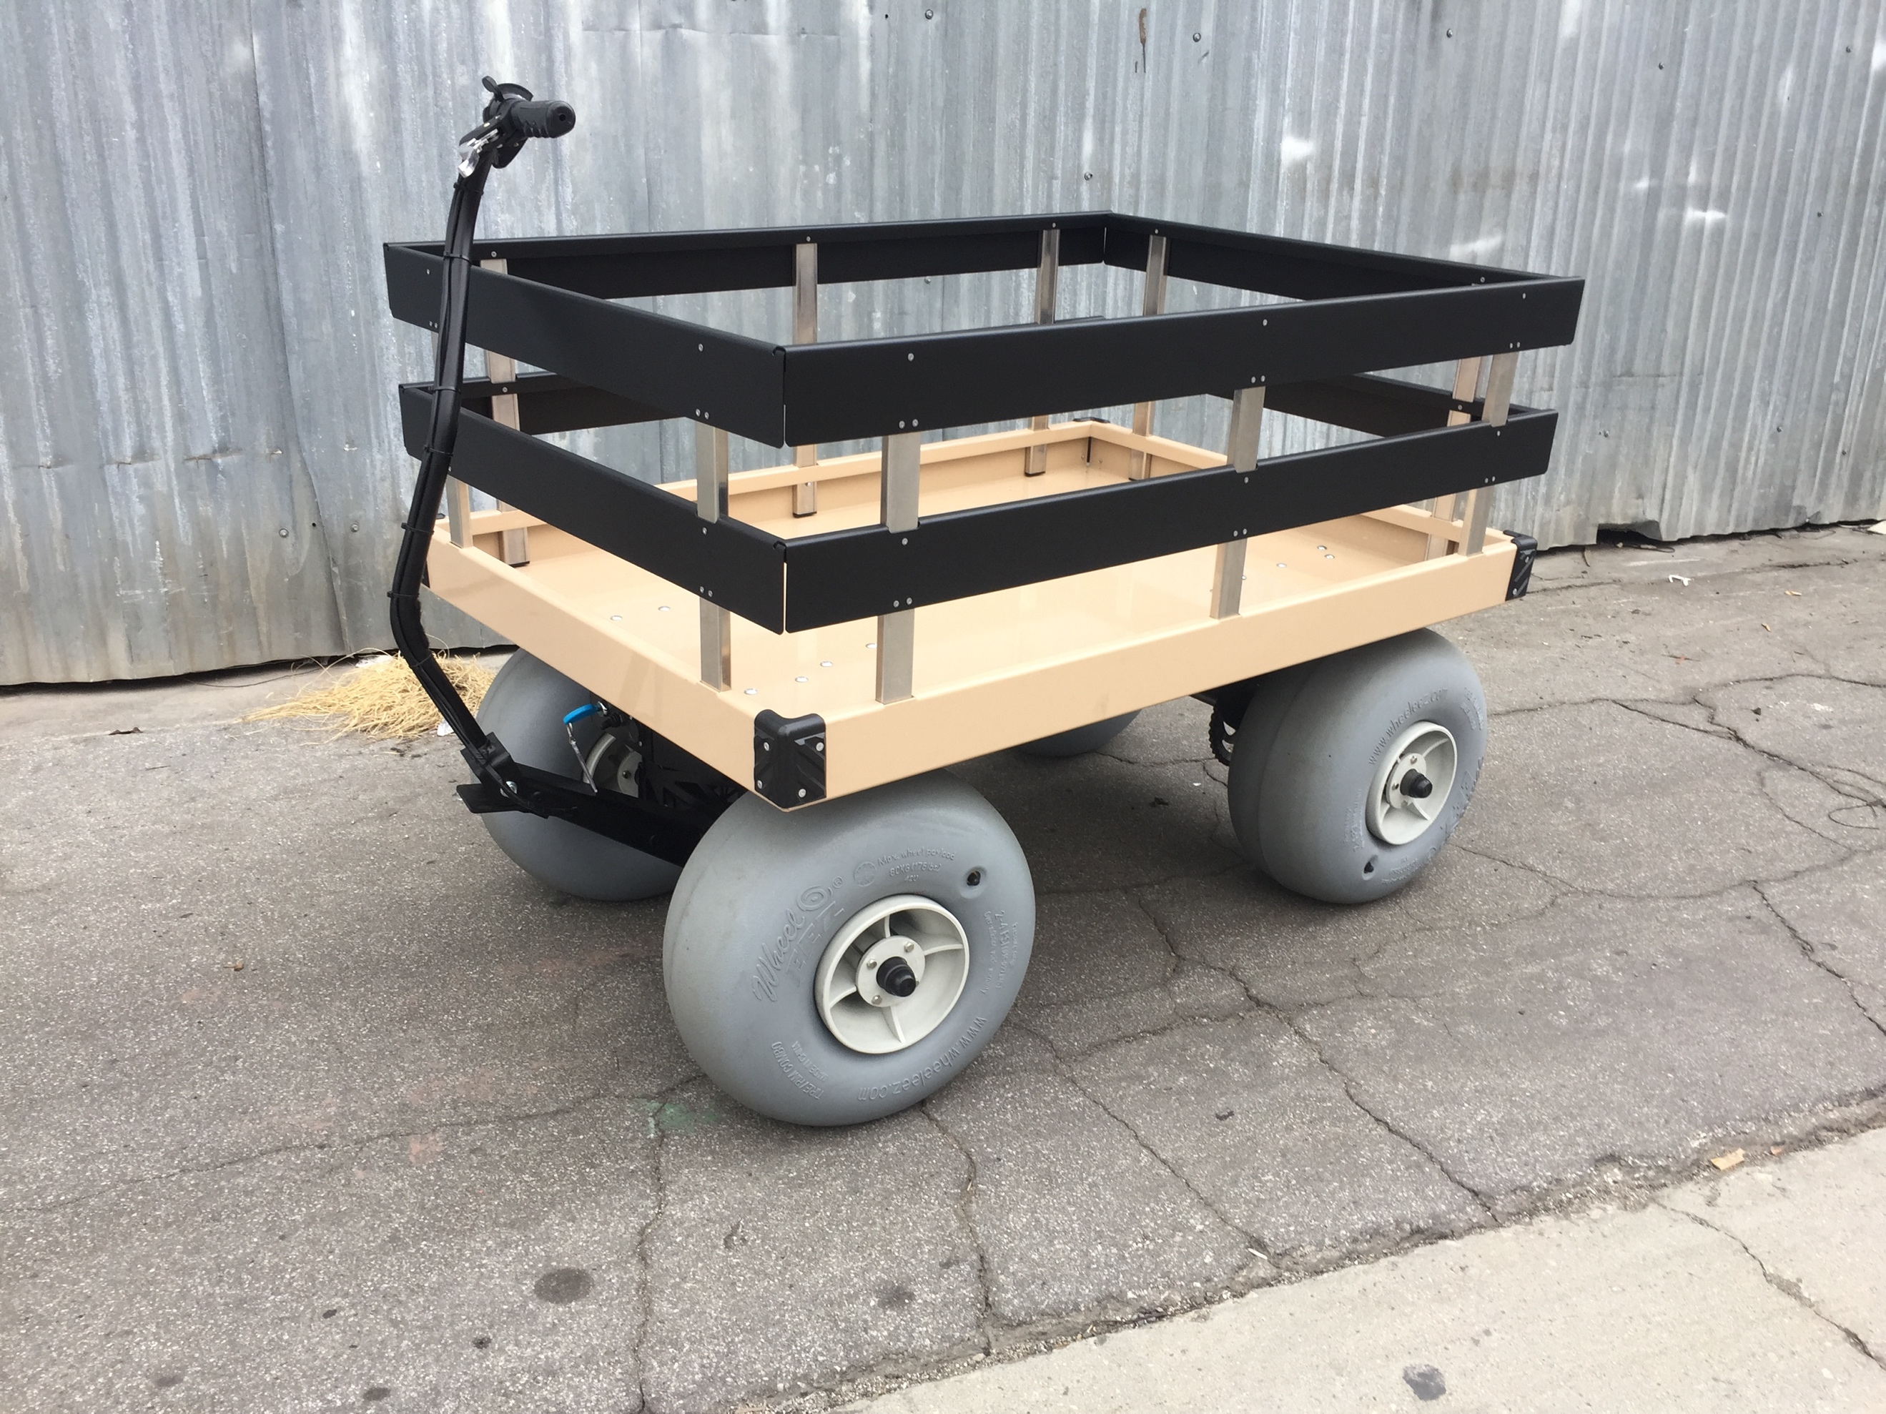

Sandhopper® with surf rack option has 1 or 2 top horizontal support beams.
Make sure they are well seated in the cutouts of the top rails.

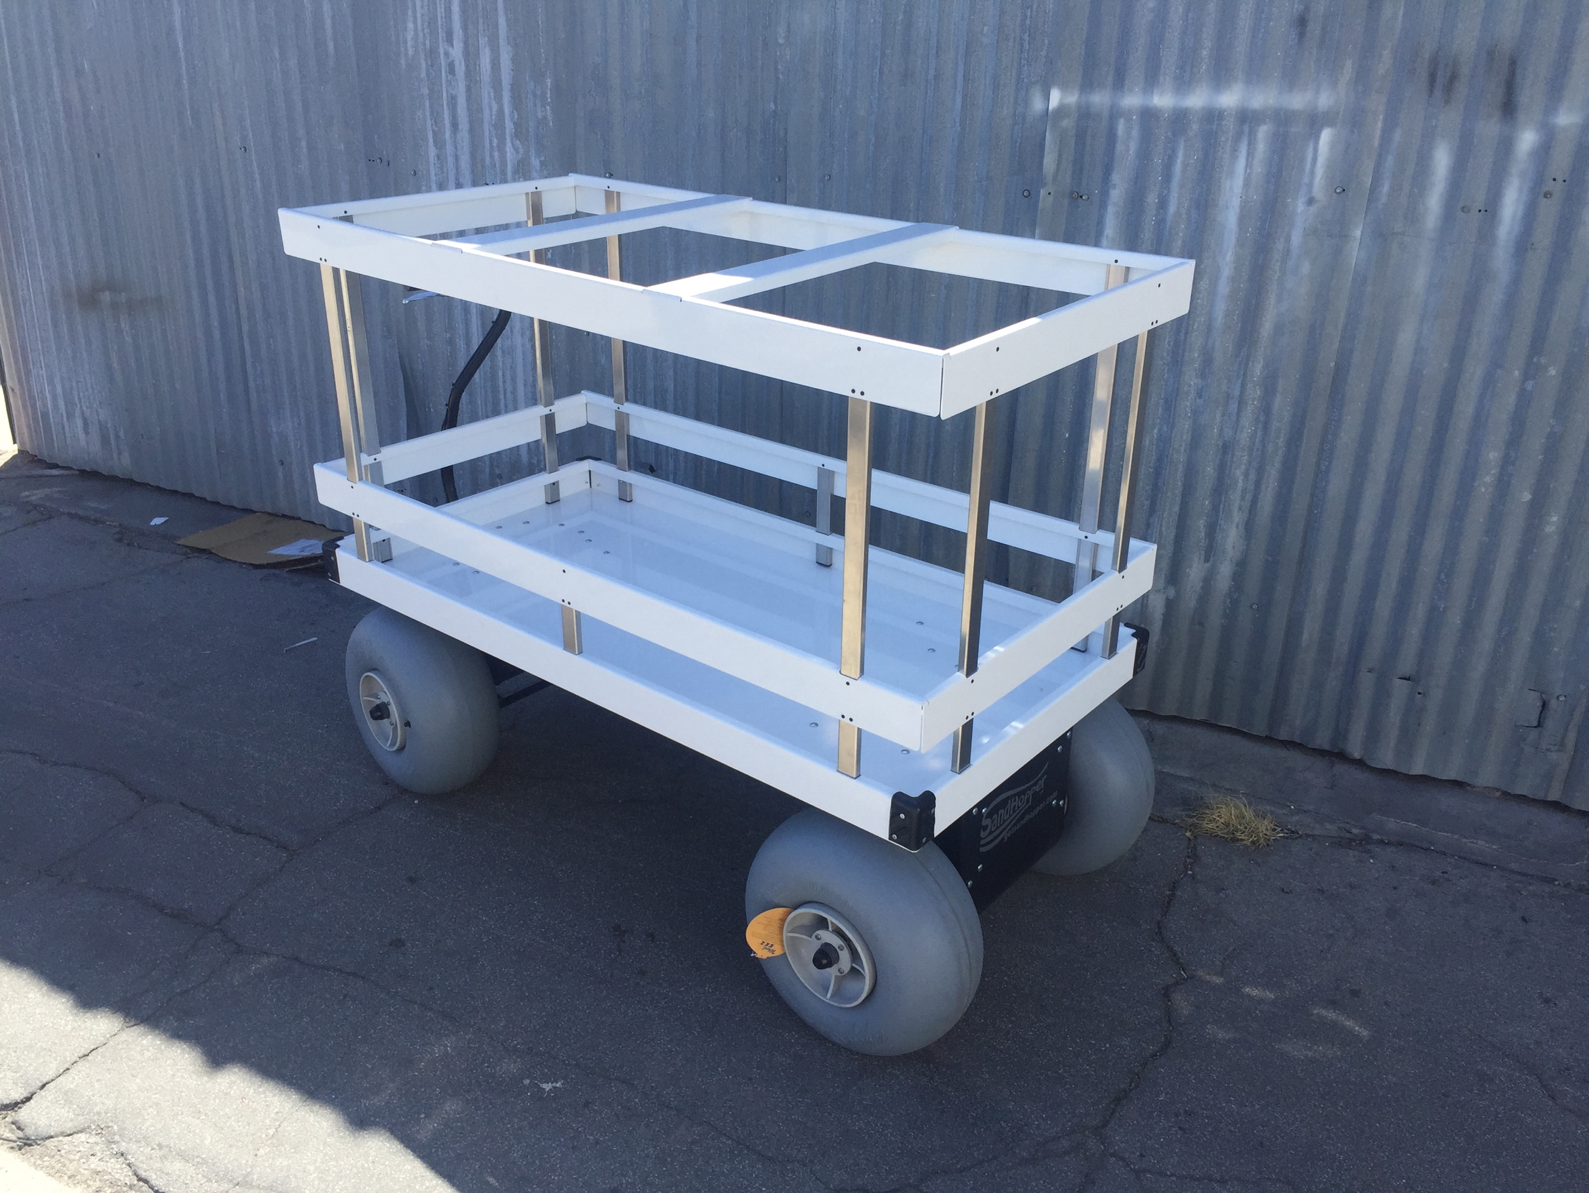

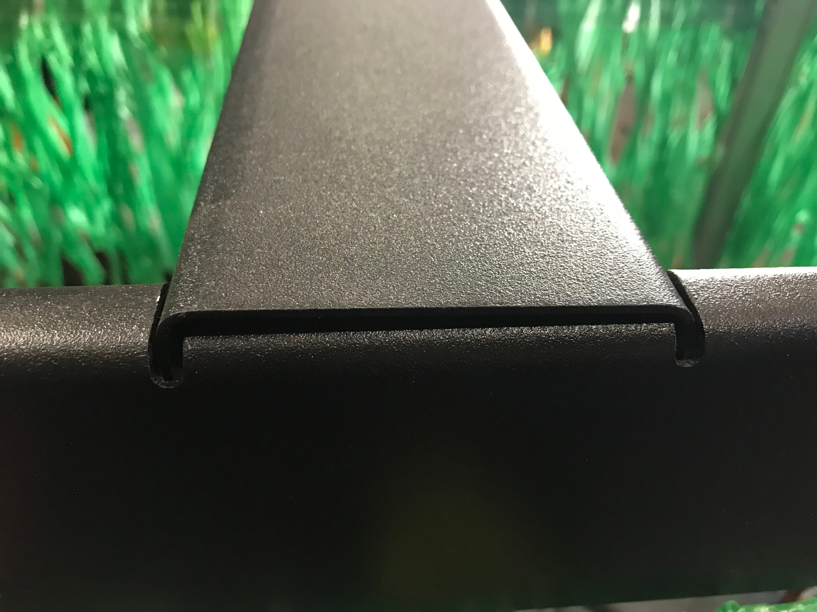

WARNING
Riding in the Sandhopper can be a hazardous activity. Do not operate the Sandhopper while sitting in it. Certain conditions may cause the equipment to fail without fault of the manufacturer. Like other wheeled products, the Sandhopper can and is intended to move, and it is therefore possible to lose control, and/or get into dangerous situations that no amount of care, instruction or expertise can eliminate. If such things occur, you or others can be seriously injured or die, even when using safety equipment and other precautions.

USE COMMON SENSE
This manual contains many warnings and cautions concerning the consequences of failing to maintain, inspect or properly use your Sandhopper. Because any incident can result in serious injury or even death, we do not repeat the warning of potential serious injury or death each time such a possibility is mentioned.

APPROPRIATE USE AND PARENTAL SUPERVISION
Direct adult supervision is required at all times. This manual contains important safety information. It is your responsibility to review this information and make sure that all operators and children obey all warnings, cautions, instructions and safety topics and assure that operators are able to safely use this product. We recommend that you periodically review and reinforce the information in this manual and that you inspect and maintain your Sandhopper to insure your and others safety. Adults or children should never attempt to ride in or on the Sandhopper wagon.

Anyone riding in the wagon or allowing others to do so, assumes full responsibility and liability for themselves and anyone else in or on the wagon and hereby releases the manufacturer, any suppliers or distributors of the Sandhopper wagon from all liability from any and all personal injury, death or property damage.

ACCEPTABLE OPERATING PRACTICES AND CONDITIONS
Direct parental supervision is required. The Sandhopper is meant to be used only in controlled environments free of potential traffic hazards and not on public streets. Never use near steps, sloped driveways, hills, roadways, alleys or swimming pool areas. Do not operate the Sandhopper in wet weather. The Sandhopper is intended for use on solid, flat, clean and dry surfaces such as pavement, beaches or level ground. Wet, slick, smooth or uneven and rough surfaces may impair traction and contribute to possible accidents. Examples include but are not limited to: Handicap access ramps made of a smooth material such as wood or other material that prevent the balloon style tires from gaining traction. Do not operate in mud, ice, puddles or water. Avoid steep inclines that can be hazardous in maintaining control of the wagon.
Never risk damaging surfaces such as carpet or flooring by using the Sandhopper indoors. Do not use at night or when visibility is impaired.

USING THE CHARGER
The charger supplied with the Electric Wagon should be regularly examined for damage to the cord, plug, enclosure and other parts, and in the event of such damage, the batteries must not be charged until the charger has been repaired or replaced. Only use the recommended charger. The charger is not a toy. Always disconnect the Sandhopper from the charger prior to wiping it down.

BATTERY
Your Sandhopper uses a sealed Lead Acid battery. Replacement batteries are readily available. Make certain you match the manufacturer’s exact specifications when replacing the battery. Batteries should always be recycled. Please contact your city or county for an appropriate disposal center.

WARRANTY
Your Sandhopper has a limited 6-month warranty. The tires and battery carry separate warranties from their specific manufacturer. See your Sandhopper warranty information card for more details or contact your authorized retailer. Don’t forget to register your purchase in order to validate your warranty. Your warranty may be void if not properly registered with the manufacturer.

FAILURE TO USE COMMON SENSE AND HEED THE ABOVE WARNINGS INCREASES RISK OF SERIOUS INJURY. USE WITH APPROPRIATE CAUTION AND SERIOUS ATTENTION TO SAFE OPERATION.

